## **Sprint Protocol 05/17/17**

* **Registry Server for Raspberry Pies**

Solution using *ARP Tables* might not be feasible within Sivantos Network.

Sivantos rely on using *Ethernet Connections*.

Use dedicated *central server / discovery service* with static IPs where Pis are connecting to.

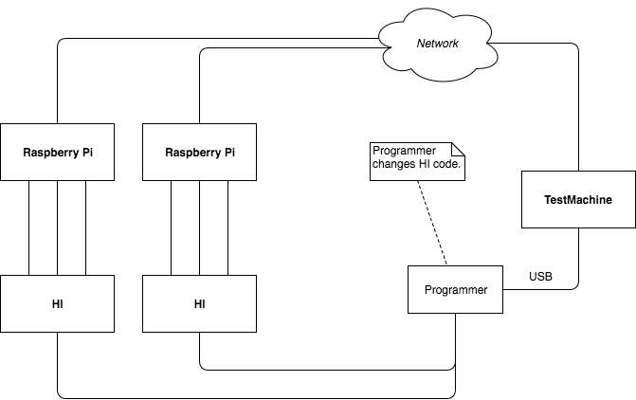

* **Testing**

Create Unit Tests.

Configure AppVeyor, finally figure out a way to do automated CI.

* **Code Clean-up**

Re-do GPIOinterface, adding additional features for ease-of-use.

Re-structure Listener on RaspberryBackend.

* **Git Branching**

Use master branch for releases / sprints only *(so no direct push to it whilst developing)*.

Use feature branches for individual components.

Use Pull-Requests to merge features that have been thoroughly tested into master branch.